Question 1
Exercise 10-12 Budgeted Sales and cash Receipts [L0 2]
Mississippi Retailers expects credit sales in the next quarter as follows:
April $ 80,000
May $ 90,000
June $113,000

Prior experience has shown that 70% of a month’s sales are collected in the month of sale, 20% are collected in the month following sale, and the remaining 10% are collected in the second month following sale. February and March sales were $90,000 and $100,000, respectively.
Required:
Estimate the cash receipts for April, May and June.
E12. [LO 2]
April May June
Collection of credit sales
Collection of February sales* $9,000
Collection of March sales** 20,000
Collection of April sales*** 56,000
Collection of March sales $10,000
Collection of April sales 16,000
Collection of May sales 63,000
Collection of April sales $8,000
Collection of May sales 18,000
Collection of June sales 79,100
$85,000 $89,000 $105,100
*($90,000 × .10)
**($100,000 × .20)
***($80,000 × .70)

Question 2
EXERCISE 6-7. Allocation of Service Department Costs [LO 1]
The building maintenance department for the Taylor Manufacturing Company budgets annual costs of $5,250,000 based on the expected operating level for the coming year. The costs are allocated to two production departments. Taylor is considering two allocation bases for assignment of costs to departments: (1) square footage and (2) direct labor hours. The following data relate to the potential allocation bases: Production Dept. 1 Production Dept. 2 Square footage 30,000 40,000 Direct labor hours 40,000 30,000
Required:
Calculate the costs allocated to the production departments using each allocation base.
Comment on which allocation base is preferable.
E7. [LO 1]
Allocation Base Prod. Dept.1 Prod. Dept.2
Square footage $2,250,000 $3,000,000
($75* x 30,000) ($75 x 40,000)
Direct labor hrs. $3,000,000 $2,250,000
($75 X 40,000) ($75 x 30,000)
* $5,250,000 ÷ 70,000 = $75
As indicated, the choice of the allocation base greatly affects the allocations of cost. Use of square footage as the allocation base assigns 57% of the cost to department 2 and 43% to department 1. However, use of direct labor hours allocates 57% of the cost to department 1 and only 43% to department 2. Department 1 would prefer to be allocated cost based on square footage and department 2 would prefer direct labor hours as the base.

Question 3
EXERCISE 4-18. Constraints [LO 3]

Dvorak Music produces two durable music stands:
Stand A Stand B
Selling price $110 $100
Less variable costs 50 64
Contribution margin $ 60 $ 36

Stand A requires 2 labor hours and stand B requires 1 labor hour. The company has only 350 available labor hours per week. Further, the company can sell all it can produce of either product.

Required:

a. Which stand(s) should the company produce?

b. What would be the incremental benefit of obtaining 15 additional labor hours?

E18. [LO 3]
- Stand A Stand B

Selling price $110 $100
Variable costs 50 64
Contribution margin 60 36
÷ Hours to produce 1 item 2 1
Contribution margin per hour $30 $36
The company should produce just stand B. With 350 hours available, this stand will generate $12,600 of contribution margin ($36 × 350 hours) while stand A will generate just $10,500 ($30 × 350).
- If the company obtains additional labor, it should produce more of stand B. The incremental benefit of 15 labor hours is $540 ($36 contribution margin per hour x 15 hours).

Question 4 E7. [LO 1]

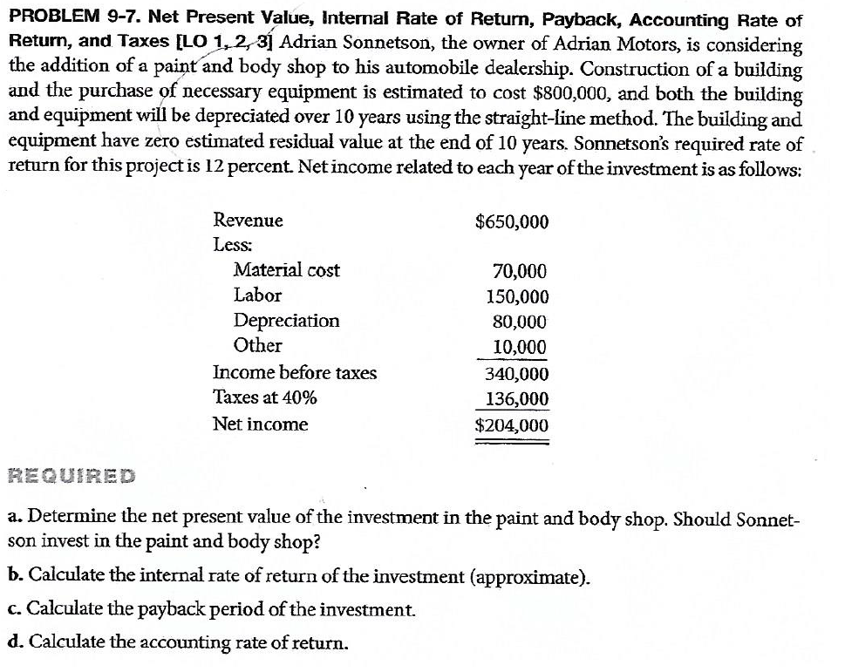
P7. [LO 1, 2, 3]
a. The net present value is positive $804,663. Thus the company should invest in the paint and body shop.

Net income $ 204,000
Add depreciation ($800,000 ÷ 10) 80,000
Annual cash flow $284,000

Cash 12% Present Value

Flow Factors PV Amounts
$284,000 5.6502 $1,604,657
(800,000) 1.0000 (800,000)
$ 804,657

b. A present value of an annuity factor of 2.8169 implies the IRR is greater than 30 percent.

Initial outlay $800,000
Annuity amount 284,000

Cost ÷ annuity = PV of annuity factor 2.8169

Note—the annuity factor for 30% is 3.0915.

c. The payback period is approximately 2.8 years:

Initial outlay $800,000
Annual cash flow 284,000

Cost ÷ annuity = number of years to
recover initial investment 2.8169

d. The accounting rate of return is 51%:

Average income $204,000
Average investment
($800,000 ÷ 2) 400,000

Average income ÷ average investment = accounting rate of return 51%

Question 5
Exercise 10-5 Sales Budget for Service Company [L O 2]
Oregon Adventures provides tours of scenic locations in Oregon. The company expects tours taken to increase dramatically compared with the prior year.
For the past year, 2017, the number of tours given were as follows.
First quarter 6,000
Second quarter 7,000
Third quarter 10,000
Fourth quarter 9,000

Required:
Assume that sales for each quarter in 2018 will be 35% higher than 2017 and that the price per tour is $75. Prepare a sales budget by quarter for 2018.
E5. [LO 2]
Oregon Adventures
Sales Budget
For the Year Ending December 31, 2018

First Second Third Fourth

Quarter Quarter Quarter Quarter Year
Sales for 2017
in units 6,000 7,000 10,000 9,000 32,000
Projected sales at
135% of prior year 8,100 9,450 13,500 12,150 43,200
Sales price per unit $ × 75 $ × 75 $ × 75 $ × 75 $ × 75
Budgeted revenue
for 2018 $607,500 $708,750 $1,012,500 $911,250 $3,240,000

Question 6
EXERCISE 4-12. CVP Analysis, Profit Equation [LO 2]
Lake Stevens Marina has estimated that fixed costs per month are $350,000 and variable cost per dollar of sales is $0.30.
Required
- What is the break-even point per month in sales dollars?
- What level of sales dollars is needed for a monthly profit of $70,000?
- For the month of July, the marina anticipates sales of $1,000,000. What is the expected level of profit?
E12. [LO 2]
- Given that variable cost per dollar of sales is $0.30, the contribution margin per dollar of sales (i.e., the contribution margin ratio) is $0.70. The break-even point equals fixed cost divided by the contribution margin ratio. Thus, the break-even point is $500,000 [i.e., $350,000 ÷ 0.70 = $500,000].

- ($350,000 + $70,000) ÷ 0.70 = $600,000

- The expected level of profit is:
($1,000,000 x 0.70) − $350,000 = $350,000.

Question 7
EXERCISE 4-14. Margin of Safety [LO 2]
Rhetorix, Inc. produces stereo speakers. The selling price per pair of speakers is $1,000. The variable cost of production is $300 and the fixed cost per month is $49,000. For November, the company expects to sell 125 pairs of speakers.
Required:
- Calculate expected profit.
- Calculate the margin of safety in dollars. (Round any percentage to two decimal places and round dollar answers to the nearest dollar.)

E14. [LO 2]

- Expected profit is $1,000 (125) − $300 (125) − $49,000 = $38,500.

- The contribution margin ratio is $700 ÷ $1,000 = 0.70
Breakeven sales are $49,000 ÷ 0.70 = $70,000

Expected sales are 125 × $1,000 = $125,000.
The margin of safety is equal to expected sales − break-even sales =
$125,000 − $70,000 = $55,000.

Question 8
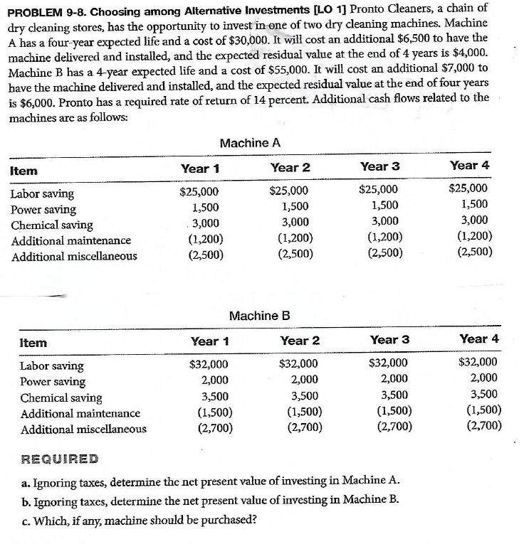

P8. [LO 1]
a. Present value of Machine A

Cash 14% PV

Annual amounts: Flow Factors PV Amounts
Labor saving $25,000
Power saving 1,500
Chemical saving 3,000
Add. Main. (1,200)
Add. Misc. (2,500)
Net annual cost
savings 25,800 2.9137 $ 75,173
Cost (30,000) 1.0000 (30,000)
Installation (6,500) 1.0000 (6,500)
Residual value 4,000 .5921 2,368
NPV $41,041

b. Present value of Machine B

Cash 14% PV

Annual amounts: Flow Factors PV Amounts
Labor saving $32,000
Power saving 2,000
Chemical saving 3,500
Add. Main. (1,500)
Add. Misc. (2,700)
Net annual cost
savings 33,300 2.9137 $ 97,026
Cost (55,000) 1.0000 (55,000)
Installation (7,000) 1.0000 (7,000)
Residual value 6,000 .5921 3,553
NPV $38,579

c. Both NPVs are greater than zero, so both are acceptable investments. However, the company should purchase machine A since it has a higher NPV.

